1. **Essay (40 point)**

The table given below lists 6 metrics for each of the 20 methods of a Java class named ‘Directory’.

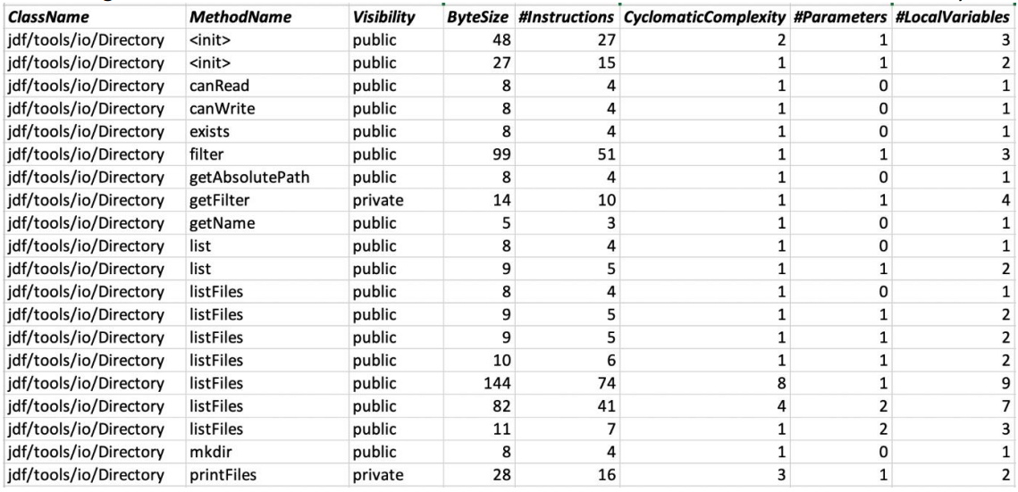

The meaning of the 6 metrics is as follows:

* Visibility: the visibility modifier of the method – one of private, protected, or public.
* #Instructions: the number of Bytecode instructions
* Bytesize: the total number of Bytes used by all instructions of this method
* CyclomaticComplexity: the cyclomatic complexity (number of decision points + 1)
* #Parameters: the number of formal parameters/arguments
* #LocalVariables: the number of local variables declared in the method

As the Java programming language supports method overloading, there are 2 methods named ‘list’ and 7 methods named ‘listFiles’ that are distinct and all have a different method parameters/arguments.

Answer the following questions and refer back to the table to illustrate/justify your answers:

1. **[LO 2, 6 points]** List the type of scale (Nominal, Ordinal, Interval, Ratio, or Absolute) for each of the 6 metrics.

**Answer:**

1. **Visibility Metrics**

A **nominal scale does not measure quantity, only type also classify members into 2 or more categories** and **must be mutually exclusive and exhaustive** means that **every category must be capable of being classified into only one category**.

**So, VISIBILITY type of scale is NOMINAL** because there **given name of class like public, protected and private**. Also **does not measure quantity and each category classified into one**.

1. **#instructions Metrics**

A **ratio scale does can be added, subtracted, and multiplied and has an absolute zero or character of origin**. Also **doesn’t have negative numbers, because of its zero-point feature**.

**So, INSTRUCTION type of scale is RATIO** because **the number of bytecode cannot be negative**. But, in other hand, **number of bytecode can be zero origin and also we can calculate mean, median, etc**.

1. **Bytesize Metrics**

A **ratio scale does can be added, subtracted, and multiplied and has an absolute zero or character of origin**. Also **doesn’t have negative numbers, because of its zero-point feature**.

**So, BYTESIZE type of scale is RATIO** because **the number of bytes cannot be negative**. But, in other hand, **number of bytes can be zero origin and also we can calculate mean, median, etc**.

1. **CyclomaticComplexity Metrics**

An **ordinal scale reports the ordering and ranking of data without establishing the degree of variation between them**. Also **known as qualitative data or categorical data. It can be grouped, named, and also ranked**.

**So, CyclomaticComplexity type of scale is ORDINAL** because **the decision points are increase by 1**. Also from the result, **only know that one is better than another but do not know by how much**.

1. **#Parameters Metrics**

An **absolute scale is a count of the elements in a set and its natural origin is zero, or the empty set used for quantities by progresses in only one direction** such as **when buy a dozen “Grade A” potato, you assume that for your purposes any “Grade A” potato are the same as any other “Grade A” potato**.

**So, PARAMETERS type of scale is ABSOLUTE** because **it can start from zero and progresses in only one direction**. Also from the result, **only know that one is better than another but do not know by how much**.

1. **#LocalVariables**

A **ratio scale does can be added, subtracted, and multiplied and has an absolute zero or character of origin**. Also **doesn’t have negative numbers, because of its zero-point feature**.

**So, LocalVariables type of scale is RATIO** because **the number of bytes cannot be negative**. But, in other hand, **number of bytes can be zero origin and also we can calculate mean, median, etc**.

1. **[LO 2, 4 points]** Do the metrics presented in the table support the statement “most methods are small”? Justify your answer.

**Answer:**

**A method or function should be kept small (both in complexity and line count)** and **if have a rather big/long method, subdivide it into smaller logic or functionality**. In the table of Metrics, it is described that **the ‘Directory’ class has been made using Java Programming Language** **based on statement** “**As the Java programming language supports method overloading, there are 2 methods named ‘list’ and 7 methods named ‘listFiles’ that are distinct and all have a different method parameters/arguments”**.

**Just looking at the table above, it's obvious that "Most methods are small" as noted by the smallish ByteSize and Cyclomatic Complexity data set**. Also, **it was stated that method overloading was used in list() and listFiles() methods (this alone will subdivide one big method into a number of smaller ones)**.

1. **[LO 2, 5 points]** Comment on how the metrics presented in the table support the statement “Software is not normal”.

**Answer:**

**"Software is not normal" is supported by the metrics presented above, because there is no standard formula for calculating the instructions set just by looking at the Bytesize or the Complexity**.

Look at the **filter() methods**, it **has a complexity of 1 and a Bytesize of 99 but it takes 51 Bytecode instructions** to perform it, **compared that to the listFiles() with complexity of 4 with a Bytesize of 82 but only 41 instructions set**.

Another example, look at the **canRead(), canWrite(), and exists() methods, it has a complexity of 1 and a Bytesize of 8 but it takes 4 Bytecode instruction** to perform it, **compared that to the printFiles() method with complexity of 3 with a Bytesize of 28 but only 16 instructions set**.

So, **for just 6 metrics information that is given in the table, can conclude that “Software is not normal”** and **must provide more metrics information to be precise and proven is the software normal or not**.

1. **[LO 2 & LO 3, 10 points]** Provide suitable summary measures (for example, average/mean, median, standard deviation etc.) for
2. #Instructions
3. CyclomaticComplexity, and
4. #LocalVariables

that provide an accurate, statistically relevant summary of the distribution of the corresponding metric.

Please justify the choice of summary measures and list the corresponding values (e.g., median of #Parameters = 1).

**Answer:**

1. **#Instruction**
2. **Mode**

The mode of a set of data is the value which occurs most frequently by order the data set from smallest to largest. In Metric Table, the ordered values become:

|  |  |
| --- | --- |
| **Number** | **Total** |
| 3 | 1 |
| 4 | 7 |
| 5 | 3 |
| 6 | 1 |
| 7 | 1 |
| 10 | 1 |
| 15 | 1 |
| 16 | 1 |
| 27 | 1 |
| 41 | 1 |
| 51 | 1 |
| 74 | 1 |
| **Grand Total** | **20** |

**So, Mode of #Instruction = 4**

1. **Median**

The median is the middle value of a set of data containing an odd number of values, or the average of the two middle values of a set of data with an even number of values. In Metric Table, the ordered values become:

|  |  |
| --- | --- |
| **Number** | **Total** |
| 3 | 1 |
| 4 | 7 |
| 5 | 3 |
| 6 | 1 |
| 7 | 1 |
| 10 | 1 |
| 15 | 1 |
| 16 | 1 |
| 27 | 1 |
| 41 | 1 |
| 51 | 1 |
| 74 | 1 |
| **Grand Total** | **20** |

Since this set of numbers has Twenty Values (Even), the median or value in the middle lies between 5 and 5. Adding 5 and 5 yields 10. Dividing 10 by two gives a median value of 5.

**So, Median of #Instruction = 5**

1. **Average**

The Average (also known as mean) obtained by dividing the sum of observed values by the number of observations for predicting subsequent data points.

|  |  |  |
| --- | --- | --- |
| **Number** | **Total** | **Sum** |
| 3 | 1 | 3 |
| 4 | 7 | 28 |
| 5 | 3 | 15 |
| 6 | 1 | 6 |
| 7 | 1 | 7 |
| 10 | 1 | 10 |
| 15 | 1 | 15 |
| 16 | 1 | 16 |
| 27 | 1 | 27 |
| 41 | 1 | 41 |
| 51 | 1 | 51 |
| 74 | 1 | 74 |
| **Grand Total** | **20** | **293** |

Insert the values into the formula to calculate the average. The average equals the sum of the values (293) divided by the number of data points (20) and the result to that is 14.65.

**So, Average of #Instruction = 14.65**

1. **Standard Deviation**

Standard deviation helps evaluate data. Numbers in the data set that fall within one standard deviation of the mean are part of the data set. Numbers that fall outside of two standard deviations are extreme values or outliers.

|  |  |  |  |  |
| --- | --- | --- | --- | --- |
| **Number** | **Total** | **Sum** | **Squared Differences** |  |
| **3** | **1** | **3** | **135,7225** |  |
| **4** | **7** | **28** | **793,9575** |  |
| **5** | **3** | **15** | **279,3675** |  |
| **6** | **1** | **6** | **74,8225** |  |
| **7** | **1** | **7** | **58,5225** |  |
| **10** | **1** | **10** | **21,6225** |  |
| **15** | **1** | **15** | **0,1225** |  |
| **16** | **1** | **16** | **1,8225** |  |
| **27** | **1** | **27** | **152,5225** |  |
| **41** | **1** | **41** | **694,3225** |  |
| **51** | **1** | **51** | **1321,3225** |  |
| **74** | **1** | **74** | **3522,4225** |  |
| **Grand Total** | **20** | **293** | **7056,55** |  |
| **MEAN** | | **14,65** | **Standard Deviation** | **19,27167** |
|  |

**So, Standard Deviation**

**of #Instruction = 19.27167**

1. **P-Value**

A p-value is a statistical value that details how much evidence there is to reject the most common explanation for the data set that can be considered to be the probability of obtaining a result at least as extreme as the one observed, given that the null hypothesis is true.

The method for finding the P-Value by first calculate the z-score and then look up its corresponding p-value using the standard normal table.

1. **Find z-score value**

**Z =**

Where:

X = Experimental Value

μ = Mean

σ = Standard Deviation

**So, z-score calculated for this problem:**

**Z =**

**Z = -0,1375**

1. **Get p-value from z-score using Microsoft Excel**

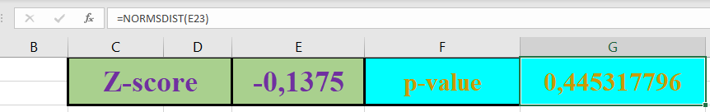

**So, p-value of #Instruction = 0,445317796**

1. **CyclomaticComplexity**
2. **Mode**

The mode of a set of data is the value which occurs most frequently by order the data set from smallest to largest. In Metric Table, ordered values become:

|  |  |
| --- | --- |
| **Number** | **Total** |
| 1 | 16 |
| 2 | 1 |
| 3 | 1 |
| 4 | 1 |
| 8 | 1 |
| **Grand Total** | **20** |

**So, Mode of CyclomaticComplexity = 1**

1. **Median**

The median is the middle value of a set of data containing an odd number of values, or the average of the two middle values of a set of data with an even number of values.

|  |  |
| --- | --- |
| **Number** | **Total** |
| 1 | 16 |
| 2 | 1 |
| 3 | 1 |
| 4 | 1 |
| 8 | 1 |
| **Grand Total** | **20** |

Since this set of numbers has Twenty Values (Even), the median or value in the middle lies between 1 and 1. Adding 1 and 1 yields 2. Dividing 2 by two gives a median value of 1.

**So, Median of CyclomaticComplexity = 1**

1. **Average**

The Average (also known as mean) obtained by dividing the sum of observed values by the number of observations for predicting subsequent data points.

|  |  |  |
| --- | --- | --- |
| **Number** | **Total** | **Sum** |
| 1 | 16 | 16 |
| 2 | 1 | 2 |
| 3 | 1 | 3 |
| 4 | 1 | 4 |
| 8 | 1 | 8 |
| **Grand Total** | **20** | **33** |

Insert the values into the formula to calculate the average. The average equals the sum of the values (33) divided by the number of data points (20) and the result to that is 1.65.

**So, Average of**

**CyclomaticComplexity = 1.65**

1. **Standard Deviation**

Standard deviation helps evaluate data. Numbers in the data set that fall within one standard deviation of the mean are part of the data set. Numbers that fall outside of two standard deviations are extreme values or outliers.

|  |  |  |  |  |
| --- | --- | --- | --- | --- |
| **Number** | **Total** | **Sum** | **Squared Differences** |  |
| 1 | 16 | 16 | 6,76 |  |
| 2 | 1 | 2 | 0,1225 |  |
| 3 | 1 | 3 | 1,8225 |  |
| 4 | 1 | 4 | 5,5225 |  |
| 8 | 1 | 8 | 40,3225 |  |
| **MEAN** | | **1,65** | **Standard Deviation** | **1,694418081** |
|

**So, Standard Deviation**

**of CyclomaticComplexity = 1.694418081**

1. **P-Value**

A p-value is a statistical value that details how much evidence there is to reject the most common explanation for the data set that can be considered to be the probability of obtaining a result at least as extreme as the one observed, given that the null hypothesis is true.

The method for finding the P-Value by first calculate the z-score and then look up its corresponding p-value using the standard normal table.

1. **Find z-score value**

**Z =**

Where:

X = Experimental Value

μ = Mean

σ = Standard Deviation

**So, z-score calculated for this problem:**

**Z =**

**Z = 1,9770**

1. **Get p-value from z-score using Microsoft Excel**

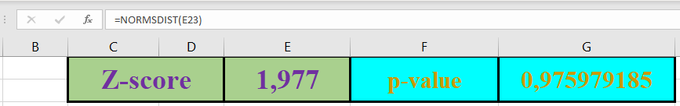

**So, p-value of**

**CyclomaticComplexity = 0,975979185**

1. **LocalVariables**
2. **Mode**

The mode of a set of data is the value which occurs most frequently by order the data set from smallest to largest. In Metric Table, ordered values become:

|  |  |
| --- | --- |
| **Number** | **Total** |
| 1 | 8 |
| 2 | 6 |
| 3 | 3 |
| 4 | 1 |
| 7 | 1 |
| 9 | 1 |
| **Grand Total** | **20** |

**So, Mode of LocalVariables = 1**

1. **Median**

The median is the middle value of a set of data containing an odd number of values, or the average of the two middle values of a set of data with an even number of values.

|  |  |
| --- | --- |
| **Number** | **Total** |
| 1 | 8 |
| 2 | 6 |
| 3 | 3 |
| 4 | 1 |
| 7 | 1 |
| 9 | 1 |
| **Grand Total** | **20** |

Since this set of numbers has Twenty Values (Even), the median or value in the middle lies between 2 and 2. Adding 2 and 2 yields 4. Dividing 4 by two gives a median value of 2.

**So, Median of LocalVariables = 2**

1. **Average**

The Average (also known as mean) obtained by dividing the sum of observed values by the number of observations for predicting subsequent data points.

|  |  |  |
| --- | --- | --- |
| **Number** | **Total** | **Sum** |
| 1 | 8 | 8 |
| 2 | 6 | 12 |
| 3 | 3 | 9 |
| 4 | 1 | 4 |
| 7 | 1 | 7 |
| 9 | 1 | 9 |
| **Grand Total** | **20** | **49** |

Insert the values into the formula to calculate the average. The average equals the sum of the values (49) divided by the number of data points (20) and the result to that is 2.45.

**So, Average of**

**LocalVariables = 2.45**

1. **Standard Deviation**

Standard deviation helps evaluate data. Numbers in the data set that fall within one standard deviation of the mean are part of the data set. Numbers that fall outside of two standard deviations are extreme values or outliers.

|  |  |  |  |  |
| --- | --- | --- | --- | --- |
| **Number** | **Total** | **Sum** | **Squared Differences** |  |
| 1 | 8 | 8 | 16,82 |  |
| 2 | 6 | 12 | 1,215 |  |
| 3 | 3 | 9 | 0,9075 |  |
| 4 | 1 | 4 | 2,4025 |  |
| 7 | 1 | 7 | 20,7025 |  |
| 9 | 1 | 9 | 42,9025 |  |
| **MEAN** | | **2,45** | **Standard Deviation** | **2,114486375** |
|

**So, Standard Deviation**

**of LocalVariables = 2,114486375**

1. **P-Value**

A p-value is a statistical value that details how much evidence there is to reject the most common explanation for the data set that can be considered to be the probability of obtaining a result at least as extreme as the one observed, given that the null hypothesis is true.

The method for finding the P-Value by first calculate the z-score and then look up its corresponding p-value using the standard normal table.

1. **Find z-score value**

**Z =**

Where:

X = Experimental Value

μ = Mean

σ = Standard Deviation

**So, z-score calculated for this problem:**

**Z =**

**Z = 1,6788**

1. **Get p-value from z-score using Microsoft Excel**

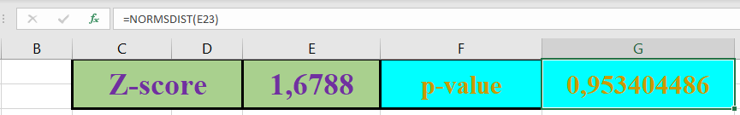

**So, p-value of**

**LocalVariables = 0,953404486**

1. **[LO 2 & LO 4, 15 points]** You have the time to thoroughly test 3 of the 20 methods of the class ‘Directory’, but no time to test the other 17 methods
2. **What is the purpose of software testing? What is to be uncovered during software testing?**

**Answer:**

1. **Purpose of software testing:**
2. **Improve Quality**

Quality means the conformance to the specified design requirement means **performing as required under specified circumstances by Debugging to find out design defects by the programmer** because the imperfection of human nature makes it almost impossible to make a moderately complex program correct the first time.

1. **Reliability Estimation**

Software reliability has **important relations with many aspects of software, including the structure, and the amount of testing it has been subjected to** **such as operational profile** (can serve as a statistical sampling method to gain failure data for reliability estimation).

1. **Got Clean Insight Into the Development Process**

Having clean insight into the process **allows better estimate costs that can know the target of the project, the possible outcome from doing this code and gain experience for the next testing process**.

1. **Things to be uncovered during software testing:**
2. **Knowing whether the application made is in accordance with the needs of the user** and **knowing whether the application made can be used by the user**.
3. **Evaluate resource usage, throughput, stimulus-response time, and queue lengths detailing the average or maximum number of tasks waiting to be serviced by selected resources**.
4. **Evaluate network bandwidth requirements, CPU cycles, disk space, disk access operations, and memory usage such as bottleneck identification**.
5. **Describe the process how you will choose the 3 methods to test and justify why this is a good process**

**Answer:**

1. **Unit Testing**

Evaluate individual components of the system to **see if these components are functioning properly on their own and each of the units selected is then tested to check whether or not it’s fully functional** also needs to have knowledge about granular levels of detail. **By applying unit testing in code changes can make sure that all issues are resolved quickly**.

1. **Integration Testing**

Evaluate individual components of the system and then **test them as a collective group** to **determine performance of individual components as a group and identify problems in interface between the modules and functions**.

1. **System Testing**

Evaluate the system can **fulfill the quality standards and complies with all major requirements and see whether or not the collective group of integrated components is performing optimally** by verifies that the **application meets the technical, functional, and business requirements specified by the customer**.

1. **Acceptance Testing**

Evaluate if the application is ready to be released for user consumption by testing by the representative customer that will **check if the application can perform all the functions specified also identify any misunderstanding of business requirements and deliver the product that customers want**.

1. **Usability Testing**

Evaluating a product or service by testing it with representative users to complete typical tasks while **observing their behavior and reactions to it and takes notes to identify any usability problems, collect qualitative and quantitative data and determine the participant's satisfaction with the product**.

1. **List the 3 methods you will test as the result of applying your process**

**Answer:**

1. **canRead()**

**With Unit Testing**, see if these **components are functioning properly on their own that can be seen by READ the FILES correctly** based on their corresponding files and check whether or not it’s fully functional.

**With Integration Testing**, test as a collective group that can be seen by **READ all FILES of all people (*Notes: Admin/CEO Account) and identify problems in interface between the modules and functions**.

**With System Testing**, check **application meets the technical, functional, and business requirements** and this case **READ FILES runs smoothly without any problem or error occurred by Internal Testers of the Company**.

**With Acceptance Testing**, check if the application **can perform all the functions specified** also **identify any misunderstanding of business requirements** and deliver the product that customers want, and this case **READ FILES by Customer Representative from outside of the Company Testers**.

**With Usability Testing**, **observing behavior and reactions to it and takes notes to identify any usability problems**, **collect qualitative and quantitative data and determine the participant's satisfaction with the current function tested**, that is **READ FILES done with Customer Representative from outside Company Testers**.

1. **canWrite()**

**With Unit Testing**, see if these **components are functioning properly on their own that can be seen by WRITE the FILES correctly** based on their corresponding files and check whether or not it’s fully functional.

**With Integration Testing**, test as a collective group that can be seen by **WRITE all FILES of all people (*Notes: Admin/CEO Account) and identify problems in interface between the modules and functions**.

**With System Testing**, check **application meets the technical, functional, and business requirements** and this case **WRITE FILES runs smoothly without any problem or error occurred by Internal Testers of the Company**.

**With Acceptance Testing**, check if the application **can perform all the functions specified** also **identify any misunderstanding of business requirements** and deliver the product that customers want, and this case **WRITE FILES by Customer Representative from outside of the Company Testers**.

**With Usability Testing**, **observing behavior and reactions to it and takes notes to identify any usability problems**, **collect qualitative and quantitative data and determine the participant's satisfaction with the current function tested**, that is **WRITE FILES done with Customer Representative from outside Company Testers**.

1. **printFiles()**

**With Unit Testing**, see if these **components are functioning properly on their own that can be seen by PRINT the FILES correctly** based on their corresponding files and check whether or not it’s fully functional.

**With Integration Testing**, test as a collective group that can be seen by **PRINT all FILES of all people (*Notes: Admin/CEO Account) and identify problems in interface between the modules and functions**.

**With System Testing**, check **application meets the technical, functional, and business requirements** and this case **PRINT FILES runs smoothly without any problem or error occurred by Internal Testers of the Company**.

**With Acceptance Testing**, check if the application **can perform all the functions specified** also **identify any misunderstanding of business requirements** and deliver the product that customers want, and this case **PRINT FILES by Customer Representative from outside of the Company Testers**.

**With Usability Testing**, **observing behavior and reactions to it and takes notes to identify any usability problems**, **collect qualitative and quantitative data and determine the participant's satisfaction with the current function tested**, that is **PRINT FILES done with Customer Representative from outside Company Testers**.

1. **Case (60 point)**

A freight forwarding company will develop a tracking system application that can provide convenience for consumers in sending goods to various locations. Some of the conveniences of this application are Consumers can send goods with a home pickup system so that consumers just make an order for delivery of goods, then the goods will be picked up and delivered to the destination location. Consumers can check the position of the goods that are on the way with their smartphone as well as the ease of making payments using various online payment systems. In addition, the application can also be used by companies to track vehicles used for shipping goods with real time information on the position, condition of the vehicle, driver's condition and information on the goods being transported. Based on this case, answer the following questions:

1. **[LO 3, 20 points]** To ensure the application quality for meeting the user needs, identify application metrics that need to be measured and how to measure them to ensure that application functionality meets user needs.

**Answer:**

1. **Performance Metrics**
2. **App Crashes**

Everyone has experienced app loads crashes at some point (an app load is the launch of an app depending on the type of app, its usage, maturity, etc.

1. **API Latency**

Apps of today leverage several API’s or services. Latency refers to the round-trip time from a request to a response to optimize to around 1 second response time.

1. **End-to-End Application Latency**

It’s not just enough to track API latencies; also need end-to-end response time to applications that are powering the APIs to optimize to around 1 second response time.

1. **App Load per Period**

This metric is related to the number of transactions or calls over a certain period of time to make sure that as the load increases, application performance doesn’t degrade when handle sudden changes in load without slowing down.

1. **Network Errors**

Network errors are typically the service provider or HTTP errors seen by the app when the app is interfacing to a networked service that lead to crashes or slow response time (with multiple retries).

1. **User, Usage & Demographics Metrics**
2. **Monthly Active Users / Daily Active Users**

The Monthly Active Users (MAU) and Daily Active Users (DAU) highlights the user base of the app on advertising for which a large user base is required in order to be successful.

1. **Devices and OS Metrics**

Apps are consumed on a wide variety of devices and need to know how/where key users use the apps such as what devices (smartphones, tablets, IoT devices) and what OS/version (iOS 8, iOS 8.x, iOS 7.x, etc.) to focus efforts on where users are.

1. **Geo Metrics**

Don’t ignore the geography aspect of app usage because this kind of data will enable to identify issues faster such as if have an app that targets a broader geography but only gets regional traction, can now start to dig into the reasons why.

1. **Engagement Metrics**
2. **Session Length**

Session length is measured as the time period between app open and close indicates how much time users are spending in app per individual session.

1. **Session Interval**

Session interval is the time between the user’s first session and their next one showing the frequency with which users open the app. This can signal the immediate value gained from downloading and running the app.

1. **Retention Rate**

Retention is measured as the percentage of users who return to app based on the date of their first visit so from that can creating better targeting opportunities and personalization of the app experience.

1. **Business Metrics**
2. **Life Time Value**

Representing the value of the app and how much each app user is worth their lifetime and isn’t limited by consider revenue as a dollar amount.

1. **Transaction Revenue**

Transaction revenue is the value of transactions supported via the mobile app that applies directly to apps that support e-Commerce transactions (shopping, travel, financial services, etc.).

1. **Abandonment Rate**

Abandonment rate is the ratio of transactions annulled to transactions initiated due to a wide variety of reasons such as the performance and experience of the app were not up to the user expectation that can help team to understand the user journey and analyze why the transaction was abandoned.

1. **[LO 4, 20 points]** Using Function Point analysis, calculate the function points for the completion of the application development project and identify the activities carried out for the development of this application in the form of WBS (work breakdown structure).

**Answer:**

1. **Work Breakdown Structure (WBS)**

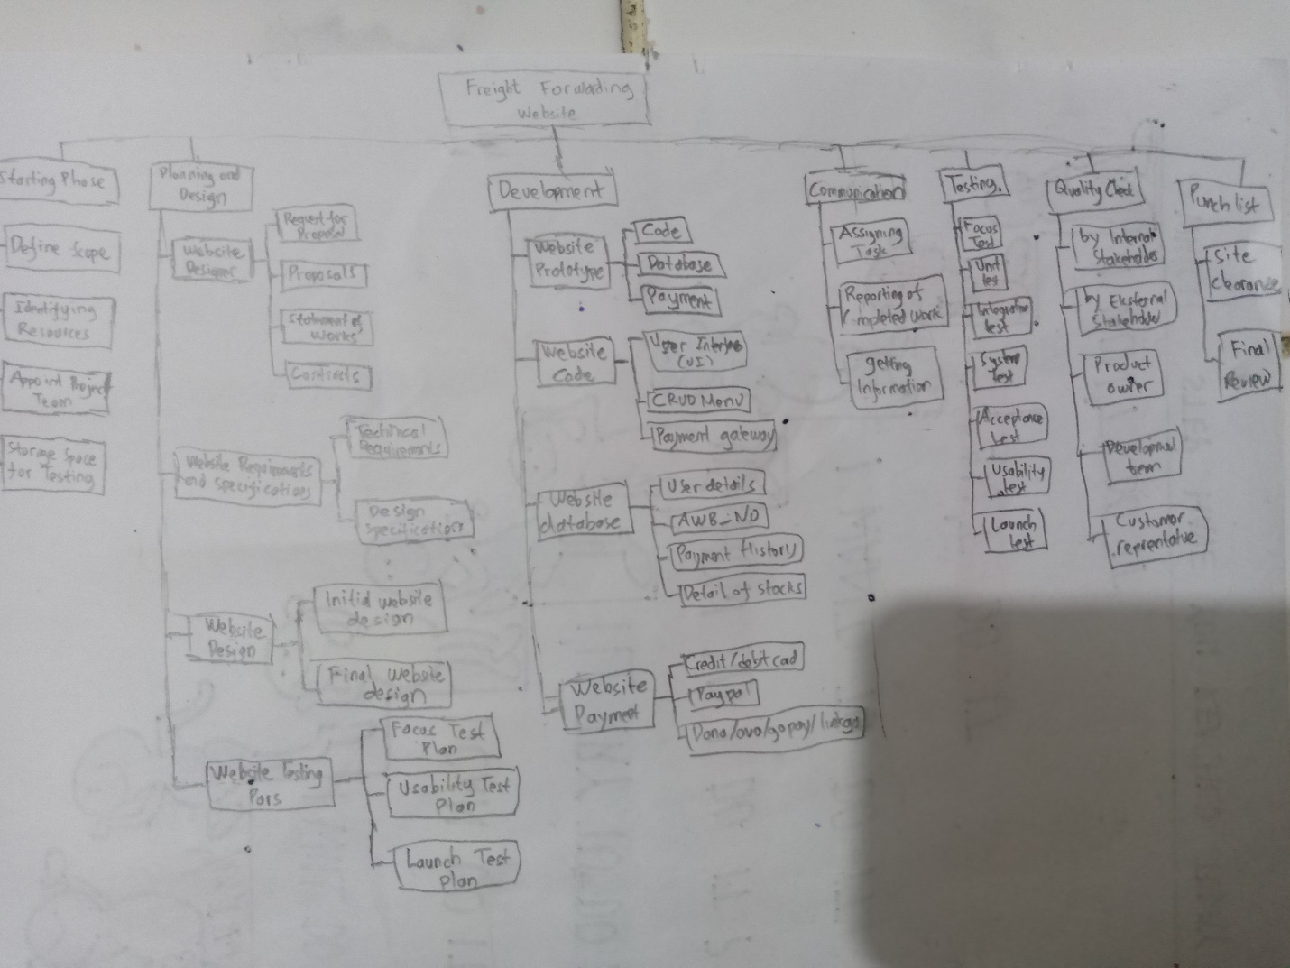

1. **Meaning of Function Point**

Function Point is a unit of measurement that measures the business functionality provided by the business product by determine whether or not a particular entry is simple, easy, average, or complex.

1. **Function Point Formula**
2. **List all the External Inputs (EIs), External Outputs (EOs), External Inquiries (EQs), Internal Logical Files (ILFs), and External Interface Files (EIFs)**
3. **External Inputs**
4. Input Email
5. Input Password
6. Choose Product
7. Choose Delivery Type
8. Choose Payment Option
9. Login to bank Application
10. Choose Transfer
11. Fill virtual booking account Number
12. Staff enter AWB_NO from delivery office
13. Customer change status to Finished
14. Customers give Comment

**TOTAL: 11**

The complexity of the inputs is not very complex. Although there are a lot of inputs happening in the software, but the inputs are very simple. There are no files to upload or inputted. The inputs only contain of the strings and numbers. **Therefore, the complexity is Simple (3)**.

1. **External Outputs**
2. Display total price include delivery fee
3. Display remaining time to complete payment
4. Display bank application on the website
5. Display invoice from process to paid
6. Display invoice from paid to delivery on progress
7. Display progress to mart online customer inbox
8. Display progress status to finished after 2 days no confirmation

**TOTAL: 7**

The Output of the software is not very simple since there are a notification output and also calculated output such as the display. Therefore, **the complexity is Average (5)**

1. **External Inquiries**
2. Customer inquiry Invoice
3. Staff see inquiry and pack product as requested
4. Customer view transaction history inquiry
5. Admin inquiry active customer each month or certain period
6. Admin inquiry all the transaction that have been done each months or certain period

**TOTAL: 5**

The external inquiries are very average. All of the inquiries such as the invoice, history, orders, products, and show customer are very usual for website application. **Therefore the complexity is average (4)**.

1. **Internal Logical Files**
2. System validate username
3. System validate password
4. System check Number of items left
5. System Calculate total price including delivery fee
6. System Changing status from process to paid
7. System Changing status to finished (if there is no confirmation)

**TOTAL: 6**

The Internal Logical File of the application is not very complex unless the password that is encrypted. However, the rest are very usual such as the username, password, check items, transaction data, status and orders are not very complex. **Therefore, the complexity is average (10)**.

1. **External Interface Files**
2. Making Virtual banking account
3. Login to user banking account that provided in website application
4. Validating and transfer money to the virtual banking account
5. Tracking Position in Real Time (Google Maps)

**TOTAL: 4**

External Interface File will be complex as the banking system is not in our grasp and we used third party application and because it is a banking application there would be complex procedure in transaction process. The tracking is not very complex since it only needs API and usually the API is easy to use. **Therefore, the complexity is complex (10)**.

1. **Break Down List into Component List Table**

|  |  |  |  |  |
| --- | --- | --- | --- | --- |
| **No** | **Component** | **FP Type** | **Complexity** | **Weighting Factor** |
| 1 | Input Email | EIs | Simple | 3 |
| 2 | Input Password | EIs | Simple | 3 |
| 3 | Choose Product | EIs | Simple | 3 |
| 4 | Choose Payment Option | EIs | Simple | 3 |
| 5 | Login to Bank Application | EIs | Simple | 3 |
| 6 | Choose Transfer | EIs | Simple | 3 |
| 7 | Fill virtual booking account Number | EIs | Simple | 3 |
| 8 | Staff enter AWB_NO | EIs | Simple | 3 |
| 9 | Customer change status to Finished | EIs | Simple | 3 |
| 10 | Customers give Comment | EIs | Simple | 3 |
| 11 | Display total price include delivery fee | EOs | Average | 5 |
| 12 | Display remaining time to complete payment | EOs | Average | 5 |
| 13 | Display bank application in the website | EOs | Average | 5 |
| 14 | Display invoice from process to paid | EOs | Average | 5 |
| 15 | Display invoice from paid to delivery on progress | EOs | Average | 5 |
| 16 | Display progress status to finished after 2 days no confirmation | EOs | Average | 5 |
| 17 | Customer inquiry Invoice | EQs | Average | 4 |
| 18 | Staff see inquiry product as requested | EQs | Average | 4 |
| 19 | Customer view transaction history inquiry | EQs | Average | 4 |
| 20 | Admin inquiry active customer each month or certain period | EQs | Average | 4 |
| 21 | Admin inquiry all the transaction that have been done each month or certain period | EQs | Average | 4 |
| 22 | System validate username | ILFs | Average | 10 |
| 23 | System validate password | ILFs | Average | 10 |
| 24 | System check Number of items left | ILFs | Average | 10 |
| 25 | System Calculate total price including delivery fee | ILFs | Average | 10 |
| 26 | System Changing status from process to paid | ILFs | Average | 10 |
| 27 | System Changing status to finished (if there is no confirmation) | ILFs | Average | 10 |
| 28 | Making Virtual banking account | EIFs | Complex | 10 |
| 29 | Login to user banking account (PayPal, Debit Card, Credit Card, Ovo, GoPay, LinkAja) | EIFs | Complex | 10 |
| 30 | Validating and transfer money to the virtual banking account | EIFs | Complex | 10 |
| 31 | Showing the location on Goods in Real Time (Google Maps) | EIFs | Complex | 10 |
| Count Total | | | | 180 |

1. **Calculate Unadjusted Function Point (UFP)**

|  |  |  |  |  |  |
| --- | --- | --- | --- | --- | --- |
| Information  Domain Value | Count | Weighting Factor | | | FP Count |
| Simple | Average | Complex |
| External Input (EIs) | 10 | 3 | 4 | 6 | 30 |
| External Output (EOs) | 6 | 4 | 5 | 7 | 30 |
| External Inquiries (EQs) | 5 | 3 | 4 | 6 | 20 |
| Internal Logical File (ILFs) | 6 | 7 | 10 | 15 | 60 |
| External Interface File (EIFs) | 4 | 5 | 7 | 10 | 40 |
| Count Total | | | | | 180 |

**The total of the total Unadjusted Function Point (UFP) is sum off all FP Count**

**UFP = (30 + 30 + 20 + 60 + 40) = 180**

**Therefore the Unadjusted Function Point (UFP) is 180.**

1. **Determine TDI Value**

|  |  |  |
| --- | --- | --- |
| No | General Systems Characteristics | Degree of Influence |
|
| 1 | Data Communications | 5 |
| 2 | Distributed Processing | 5 |
| 3 | Performance | 3 |
| 4 | Heavily Used Configuration | 2 |
| 5 | Transaction Rates | 3 |
| 6 | Online Data Entry | 5 |
| 7 | Design for End User Efficiency | 4 |
| 8 | Online Update | 5 |
| 9 | Complex Processing | 5 |
| 10 | Usable in Other Applications | 1 |
| 11 | Installation Ease | 1 |
| 12 | Operational Ease | 5 |
| 13 | Multiple Sites | 5 |
| 14 | Facilitate Change | 2 |
| **TDI VALUE** | | **51** |

**Therefore the TDI VALUE is 51**

1. **Calculate Value Adjustment Factor (VAF)**

**Value Adjustment Factor (VAF)’s formula:**

**Put the TDI Value to the formula:**

**Therefore the Value Adjustment Factors (VAF) is 1.16**

1. **Calculate Function Point (FP)**

**Put the UFP Value and VAF Value to the formula:**

**Therefore the Function Point (FP) is 208.8**

1. **[LO 5, 20 points]** If you are asked to lead the development of this application which will be developed in a distributed manner to team members who are in several cities, make the right configuration management software and application architecture model.

**Answer:**

**Software is like a baby elephant, cute and fun when it’s little, but once it gets big, it is difficult to steer and resistant to change**. So, **must focus on a single business capability (e.g., shopping cart, search, customer review)**.

**Instead of building one big program, the goal is to create a number of different tiny programs** and **then create a new little program every time someone wants to add a new feature**.

**With all the reasons above, the Microservice Architecture is the right Application Architecture Model**. **In this Study Case (Freight Forwarding Company), Microservice Architecture Model (Back End) can be built like:**

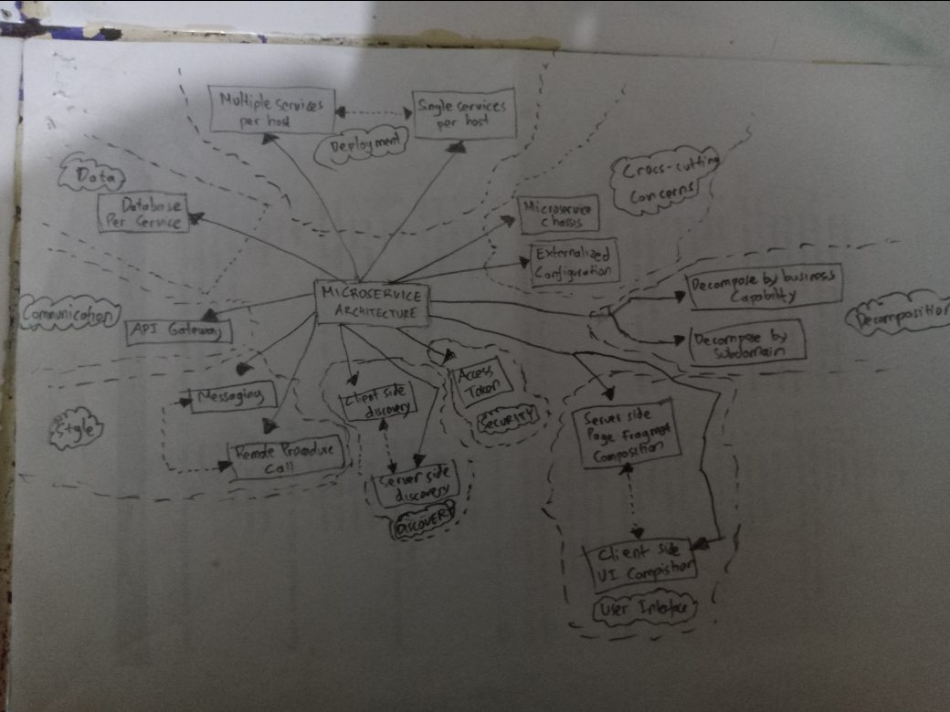

**In this Study Case (Freight Forwarding Company), Microservice Architecture Model (Front End) can be built like:**

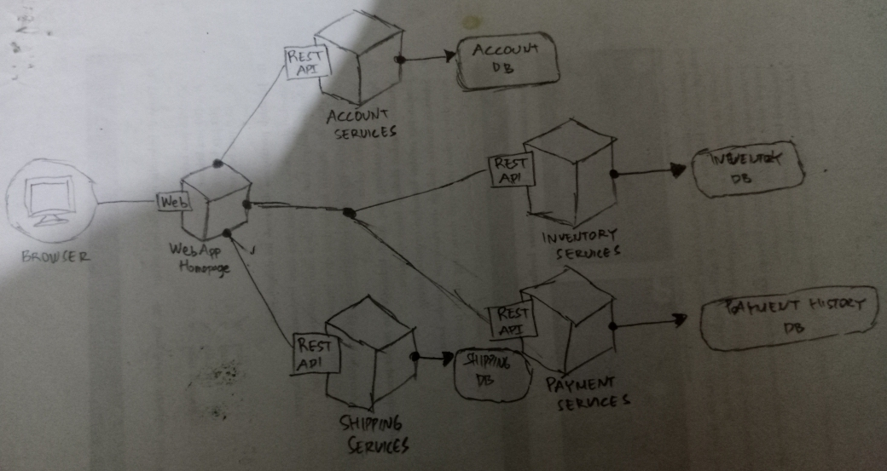

**For Configuration Management Software:**

**As it is online booking system, requirements needed to be changed regularly** based on the availability of goods, finding a courier of delivery ,keeping a database of the tracking and courier.

**Unclear User Requirement like Booking and Payment goods delivery**. One example is the Home Pickup System, it is for limited number of pickup in a day and at a appointed time by certain rules or not, that is not stated in the Case.

**Short Time Schedule like allows user to track the location real time**, see condition of the vehicle, driver's condition and information on the goods being transported, so develop the app to handle this functions in a fast and reliable way.

**Strong Project Management like check the position of the goods that are on the way with their smartphone** so user can know about their delivery status in application.

**Cost limitation like payments using various online payment systems** but in other hand, it is easy to track and easier for financial records, reduce paper used, that can used excel and other technology tools to develop it.

**Visibility of Stakeholders like track vehicles used for shipping goods services that cover any inquiries related to information delivery** so stakeholders and other end user can monitor the progress development, legal of the goods, delivery information, etc.

**Scrum is the right Configuration Management Software for rebuilding of the application based on current requirements** needed to change like Unclear User Requirement, Short Time Schedule, Strong Project Management, Cost limitation, Visibility of Stakeholders.

**Because of Unclear User Requirements, I will make assumptions to this study case**. **So, my assumptions:**

1. **Because this is Web/App application**, **customer must Register and Login First** Before Using the Web/App Application.
2. **In the case explanation**, **all purchase will be done with various online payment systems**. So, **the payment must be using Third-Party like PayPal, Credit Card, or Debit Card, Also Bank Transfer**.
3. **The application will show the remaining time to complete the payment**.
4. **The customer can inquiry the invoice to track the progress**.
5. **After** the customer **complete the payment** and the **status invoice** in apps **will change from process become paid**.
6. The **staff will be checking the usability of the product** as requested in invoice.
7. The **staff will enter the AWB_NO** and **change the status invoice become on delivery progress**.
8. **After** the **customer receive the product** then the customer will **change the status become finished**.
9. The **system will automatically change the status become finished if after two days no confirmation from the customer**.
10. The **customer can give comment for the delivery quality**.
11. The **customer can view the transaction history inquiry**.
12. The **Admin can inquiry all the transaction that have been done each months or certain period**.
13. The **Admin can inquiry the active customer each months or certain period**.
14. For **security purpose**, there are logically file to **encrypt the customer account password**.

**The Application will be developed in a distributed manner to team members**. **So, I will be declared Team Members involved in this project like:**

1. **Scrum Master**

* Ensure Sprint Creation and Planning process went smoothly.
* Ensure remove barriers that have impact on productivity.
* Facilitate meetings between the product owner and the development team

1. **Chief Technology Officer (CTO)**

* Ensure technology resources satisfy the product short and long-term needs.
* Make decisions on behalf of the company’s technological requirements.
* Communicate tech-strategy to partners and investors.
* Supervise system infrastructure to ensure functionality and efficiency.

1. **Stakeholder**

* Involved in the project or have interests that affected by the project’s outcome.
* Ensure all strategic business objectives meet the expectation.
* Ensure Project Progress in the right direction.

1. **Chief Finance Officer (CFO)**

* Reviewing all formal finance and IT related procedures.
* Establishing and developing relations with senior management and external partners and stakeholders.
* Providing strategic recommendations to the CEO/president and members of the executive management team.
* Managing the processes for financial forecasting and budgets and overseeing the preparation of all financial reporting.

1. **IT General Manager**

* Ensure employees are motivated and productive.
* Design strategy and set goals for growth of the company.
* Evaluating performance and productivity.
* Generating reports and giving presentations.

1. **IT Manager**

* Monitor performance of information technology systems to determine cost and productivity levels, and to make recommendations for improving the IT infrastructure.
* Overseeing and determining timeframes for major IT projects including system updates, upgrades, migrations, and outages.
* Running regular checks on network and data security.
* Designing training programs and workshops for staff member.
* Running and sharing regular operation system reports with senior staff.

1. **Product Owner**

* Ensure Development team develop software based on Product Owner rules.
* Ensure Product Backlog is defined properly.
* Ensure every progress of the task going based to the user stories.

1. **UI & UX Manager**

* Ensure UI Designer worked based on the Sprint Planning and Product Backlog Grooming Priority.
* Ensure UX Designer worked in the right track based on Backlog Grooming Priority dan Sprint Planning.

1. **DevOps Manager**

* Evaluates technological choices (network/hardware related and technology/code related) by querying providers and providing evaluations of each solution include ROI evaluations in the present and future implications, limitations, and opportunities.
* Manages analysis and approval of new code through security and performance gates that will design and develop for feature-complete software. Be an advocate for security and performance standards in the organization.
* Manages operational aspect of production and development servers including developing, training in, and validating compliance with procedures and checklists related to disk space usage, monitoring solutions, deployment, conventions, access to the production and development sources, source control access and usage, performance monitoring, code modifications validation, scheduling, and more.

1. **Back End Developer**

* Developing ideas for new programs, products, or features by monitoring industry developments and trends.
* Compile and analyze data, processes, and codes to troubleshoot problems and identify areas for improvement.
* Collaborating with the front-end developers and other team members to establish objectives and design more functional, cohesive codes to enhance the user experience.

1. **Front End Developer**

* Determining the structure and design of web pages.
* Ensuring web design is optimized for smartphones.
* Building reusable code for future use.
* Optimizing web pages for maximum speed and scalability.
* Utilizing a variety of markup languages to write web pages.
* Maintaining brand consistency throughout the design.

1. **UI Designer**

* Develop standard UI components and style guides for company-wide use.
* Effectively communicate designs to developers and other key stakeholders.
* Address product, marketing, and business needs.
* Conduct industry research and stay up to date on best practices, competitor UI designs and emerging technologies.
* Provide support and internal training.
* Conduct, observe and analyses usability testing sessions.
* Develop consistent, intuitive architectures.

1. **UX Designer**

* Create prototypes and wireframes.
* Conduct usability testing.
* Create user stories, personas, and storyboards.
* Plan and conduct user research and competitor analysis.

1. **Software Tester**

* Interacting with clients to understand product requirements.
* Participating in design reviews and providing input on requirements, product design, and potential problems.
* Reviewing software requirements and preparing test scenarios.
* Executing tests on software usability.
* Analyzing test results on database impacts, errors or bugs, and usability.

**Next, I will be declared Draft Activities for each process in my Configuration Management like:**

1. **Define User Stories**

**Customers:**

* Story 1: As a customer I want to be able to access to application.
* Story 2: As a customer I want to be able to send goods through delivery services or instant courier services.
* Story 3: As a customer I want to be able to real time track goods through application services.
* Story 4: As a customer I want to be able to use Home Pickup System services through application services.
* Story 5: As a customer I need to be able to pay the total invoice with services that application provided.

**System Administrator:**

* As a system administrator I want to be able to add a new booking Number to the system and set detail such as sender name, destination, giver location, goods category, etc.
* As a system administrator I want to be able to assign how much fines will be deducted if member late to returned books after the due date.
* As a system administrator I want to be able to update the total of the goods deliver include the image of each goods, in case there is goods went missing or misplace.\

**System IT Manager**

* As a system IT manager I want to be able to Ensure that all the entities involved have the proper privileges and there should not be any information leakage due to inappropriate privileges.
* As a system IT manager I want to be able to Ensure the network traffic on the system in manageable and system runs smooth with a good performance.
* As a system IT manager I want to be able to Develop a backup mechanism in case of database inconsistency or database failures.

**Chief Executive Officer (CEO)**

* As a Chief Executive Officer I want to be able to post new announcement or any change in policy to the system.
* As a Chief Executive Officer I want to be able can directly talk to any admin or manager related to any system matter.
* As a Chief Executive Officer I want to be able to view the reports corresponding to each delivery, staff, and courier and there should be report with certain performance metrics in report.

1. **Define Sprint length**

* **There will be 6 sprints for the backlog items**.
* **Each sprint will be 3 weeks long (120 hours) 🡪 15 days**.

1. **Appoint a Scrum Master**

* **Scrum Master** role is **to make the team process oriented**. All the activities of the Scrum Life Cycle are followed with due diligence are taken care be Scrum Master.
* **So, Scrum Master will be** **Project Manager** as he would be **aware about the progress of the development and team itself**.

1. **Appoint Product Owner**

* **Product owner’s** role is to **define the user stories and create a process as to how we will be developing the software/system**. Also takes the lead in defining the core features that the system should have.
* **So, Product Owner will be** **Chief Executive Officer** as he would be **aware about the software development process**.

1. **Do Product Backlog Indicator Definition with Backlog Grooming**
2. **First Priority**

* Report generation at courier, staff and delivery level which includes personal data.
* Get the report of all activities that happen in the system such as promotion day, event festival and so on.
* Creating a backup Database for the purpose of 100% availability of the system.

1. **Second Priority**

* Announcement to customer or courier or both for the important message needed such as an accident in the system.
* See the report of all couriers for certain month.
* See overall delivery and pickup system from the start of the year until end of the year.

1. **Third Priority**

* Add a new courier member to the system and give him/her applicable privileges.
* Able to assign the staff to various department and assign courier of a delivery to a particular location.
* Customers can track the delivery status from vehicles in a real time through the application.

**After that, I will conduct Sprint Planning for it, the planning like:**

1. **First Priority Sprint Planning**

**First Sprint**

* Proof of Concept (Feasibility Check) will be done for both the outstanding items.
* Any impediment or blockers will be resolved to start the actual development.

**Second Sprint**

* 3 days 🡪 Making of Delivery level reports.
* 3 days 🡪 Making of Staff level reports.
* 3 days 🡪 Making of Courier level reports.
* 2 day 🡪 Doing an integration testing for all those reports.

1. **Second Priority Sprint Planning**

**Third Sprint**

* 3 Days 🡪 Creation of new database as a backup of existing.
* 4 Days 🡪 Establishing the connection between primary and backup database.
* 5 Days 🡪 Testing the backup database by manually failing the primary one.

**Fourth Sprint**

* 3 Days 🡪 System to be able print all invoice in a delivery report card for cases in any problem occurred.
* 2 Days 🡪 Report all selling for certain month for staff.
* 2 Days 🡪 Download one file given by the report.
* 3 Days 🡪 Able to see overall grades from the very first semester.
* 4 Days 🡪 Testing all development.

1. **Third Priority Sprint Planning**

**Fifth Sprint**

* 4 Days 🡪 Making an announcement for the resident of company.
* 3 Days 🡪 report of all the staff and courier data.
* 2 Days 🡪 Report all activities in company.
* 5 Days 🡪 Testing all development.

**Six Sprint**

* 5 Days 🡪 Report of all activities that happen in the system such as promotion day, event festival and so on.
* 1 Days 🡪 Administrator can add a new staff member to the system and give him/her applicable privileges.
* 3 Days 🡪 Administrator able to assign the courier to various location and assign staff of a company to a particular department.
* 1 Days 🡪 CEO able to give the rights to admin or manager to announce important news.
* 5 Days 🡪 Testing all development.

**Next, I will describe what was done in the sprint execution stage like:**

1. **First Priority Sprint Planning**

**First Sprint**

* Proof of Concept (Feasibility Check) will be done for both the outstanding items.
* Any impediment or blockers will be resolved to start the actual development.

**ALL TASK DONE IN THIS SPRINT**

**Second Sprint**

* 3 days 🡪 Making of Delivery level reports.
* 3 days 🡪 Making of Staff level reports.
* 3 days 🡪 Making of Courier level reports.
* 2 day 🡪 Doing an integration testing for all those reports.

**THERE IS DELAY FOR 1 DAYS FOR EACH LEVEL REPORT**

**SO, TOTAL 3 DAYS OF DELAYED IN THIS SPRINT**

1. **Second Priority Sprint Planning**

**Third Sprint**

* 3 Days 🡪 Creation of new database as a backup of existing.
* 4 Days 🡪 Establishing the connection between primary and backup database.
* 5 Days 🡪 Testing the backup database by manually failing the primary one.

**THERE IS DELAY FOR 2 DAYS**

**ON SEE ESTABLISHING CONNECTION TASK**

**Fourth Sprint**

* 3 Days 🡪 System to be able print all invoice in a delivery report card for cases in any problem occurred.
* 2 Days 🡪 Report all selling for certain month for staff.
* 2 Days 🡪 Download one file given by the report.
* 3 Days 🡪 Able to see overall grades from the very first semester.
* 4 Days 🡪 Testing all development.

**THERE IS DELAY FOR 1 DAYS**

**ON SEE OVERALL STUDENT GRADES TASK**

1. **Third Priority Sprint Planning**

**Fifth Sprint**

* 4 Days 🡪 Making an announcement for the resident of company.
* 3 Days 🡪 report of all the staff and courier data.
* 2 Days 🡪 Report all activities in company.
* 5 Days 🡪 Testing all development.

**THERE IS DELAY FOR 1 DAYS**

**ON REPORT ALL ACTIVITIES IN SCHOOL TASK**

**Six Sprint**

* 5 Days 🡪 Report of all activities that happen in the system such as promotion day, event festival and so on.
* 1 Days 🡪 Administrator can add a new staff member to the system and give him/her applicable privileges.
* 3 Days 🡪 Administrator able to assign the courier to various location and assign staff of a company to a particular department.
* 1 Days 🡪 CEO able to give the rights to admin or manager to announce important news.
* 5 Days 🡪 Testing all development.

**ALL TASK DONE IN THIS SPRINT**

**After Sprint Execution, do Sprint Review Stages like:**

* **Some delay occurs during the sprint execution**.
* **Discuss What are the possible causes of the delay**, especially in the case of making the level reports, where the delay was quite large.
* **Also Discuss How to anticipate these problems in future**.

1. **Expansion of Functionality**

* New functionalities continue to be conceived and requested as the project proceeds. The software can never be completed in this way.

**Anticipation:** Signed the Memorandum of Understanding (MoU) and Memorandum of Agreement (MoA) between Stakeholders, Project Manager, and the Team.

1. **Overly Optimistic Schedules**

* Pressure on the project team because of the (unrealistic) deadlines. These attempts lead to sloppy work and more errors, which cause further delays.

**Anticipation:** Complete a project (more) quickly sometimes arises for primarily strategic reasons. If it is not feasible, however, it should not be attempted.

1. **Customers Fail to Fulfil Agreements**

* When customers do not react in a timely manner to areas in which they must be involved, projects can come to a standstill.

**Anticipation:** Give warnings max. 3 times to customer. If Fail the Agreement again, charge more money for the project or no accept other project from that customer again.

1. **Tension between Customers and Developers**

* Because the project is not proceeding quickly enough as it disturbs the necessary base of trust and the working atmosphere.

**Anticipation:** Because User involve in the Sprint, user must know detailed so the misunderstanding can be reduced.

1. **Mediocre Personnel**

* Insufficiently qualified personnel can cause project delays as do knowledge and skills in working together to play the game of the project.

**Anticipation:** Signed the Memorandum of Understanding (MoU) and Memorandum of Agreement (MoA) between Stakeholders, Project Manager, and the Team.

**Last Step, do Sprint Retrospective Stages like:**

* **Identify insights what worked well, what didn’t work well and what are the opportunity to do things differently**.
* **Worked Well**
* Done a very good job In Sixth Sprint, all of them done completely without any delay.
* Done a very good job In Fourth Sprint. From 5 tasks, only 1 times delay and only for 1 days.
* Done a very good job In Fifth Sprint. From 4 tasks, only 1 times delay and only for 1 days.
* Done a very good job In First Sprint, all of them done completely without any delay.
* **Didn’t Work Well**
* Not very good at Second Sprint of The Development, because there is a lot of delay happened on that task total 3 days.
* Not very good at Third Sprint of The Development, because there is a lot of delay happened on that task total 2 days.
* There is some task that the person who work on that task had less knowledge and skills in that task.
* The lack of people to do on this project is because the time each task is made is very small, causing a lot of delay.
* **Opportunity to do Things Differently**
* Make Sprint Planning more flexible.
* This Project can be done using with Swarming Techniques.
* Recruit more people or the hours each task can be extended.

**So, Based on Above Explanations:**

**It is right to use Microservice Architecture**

**And**

**Configuration Management Software using Scrum Technique**